Minutes of the meeting of Fringford Parish Council,
held on Monday 20th May 2024 at 7.45pm.

Present: Councillors: Ginny Hope (Chair), Les Harris, Phil Davids-Austin, Hayley Ryder, Cllr MacKenzie

Also present: R. Damerell (Clerk) and 23 members of the public.

- Appointment of Chair
- Cllr Harris nominated Cllr Hope as Chair of Fringford Parish Council, seconded by Cllr MacKenzie and unanimously approved.

- Appointment of Vice Chair
- Cllr Ryder nominated Cllr Harris as Vice Chair of Fringford Parish Council, seconded by Cllr MacKenzie and unanimously approved.

- Appointment of Councillor for Internal Financial control
- Cllr Hope proposed Cllr Davids-Austin as Councillor for Internal Financial Control, seconded by Cllr Ryder and unanimously approved.

- Appointment of Village Hall Representative
- Cllr Harris proposed Cllr Gue as the Village Hall representative for the Parish Council, seconded by Cllr MacKenzie and unanimously approved.

- Appointment of Staffing Committee
- Cllr Hope proposed Cllr Ryder as the Councillor on the Staffing Committee, seconded by Cllr Davids-Austin and unanimously approved.

- Apologies for absence
- Apologies were received for Cllr McCullagh & Cllr Gue.

- Requests for Dispensations and Declarations of interest, gifts and hospitality
- Cllr Harris declared an interest in planning application 24/00899/OUT - Land Adjoining The Cottage, The Green, Fringford

- Public participation
- Cllr Hope opened the floor to residents to ask questions regarding planning application 24/00899/OUT - Land Adjoining The Cottage, The Green, Fringford
- A resident commented that a protected oak tree at Weston on the Green along a footpath on a new housing development had been impacted by the footpath and subsequently the footpath had to be removed, this could be a similar issue to the proposed footpaths for this application and there is a protected oak tree on the site.
- Q. Did we know how effective proposed attenuation fence is that would be near The Cottage?
- A. The developers misunderstand the needs of the resident. It was thought that the noise was the problem and to solve this the intention was to erect a six-foot fence around the property, effectively imprisoning the resident. Representation regarding the negative impact on the resident will be submitted to Cherwell Planners.
- The owner of the Old Bake House owner confirmed that no communication has been received by her from the developers
- A resident raised confusion over the submission date for the submission of comments to the Cherwell Planning portal. Cllr Hope confirmed that she had been in contact with the planning team, and that the Assistant Director of planning apologised for the confusion on the portal regarding the response deadline. As it stands this evening the submission deadline is 7th June. However, this likely to change as developers did not display the statutory notice. The Parish Council has had notification that the senior planning officer is coming to the site on 21 May to see if there is a planning notice and display one if there isn’t one. The Parish Council suggests that residents work towards 7 June as the deadline to submit comments. Cllr Hope stressed it is very important for all residents to submit comments on the portal as the Parish Council is just one consultee. Cllr Hope has alerted Cllr Barry Wood and briefed him on this application, and he has requested this application is brought to the planning committee and not considered by a delegated officer.
- Q. How do we ensure that OCC Highways attend and undertake a site visit?
- Cllr Hope has emailed the Head of Highways and requested on the reasons of highways safety and the issues of the proposed footpaths not being viable, for a Highways officer to carry out a site visit. The response has been passed onto the team with a response due by Friday 17th May but nothing has been received. Cllr Hope has now escalated this for a response.
- Q. Has the Council considered the narrowness of the lane and how the developers are planning to get all equipment on site?
- A. Cllr Hope responded to state that this can be added to people’s objections, with the hope that the application is refused and avoid this becoming an issue.
- Q. Is the village clear where there could be development in the village?
- Cllr Hope responded that Fringford is reclassified as as a small village in the Cherwell 2040 draft Local Plan and therefore minor levels of development could be considered such as in-fill. This application for 10 large houses by its scale is neither minor development of in-fill. The Parish Council discussed the grounds for objection which in summary are:

that this new application is not materially different to the previous application 21/02553/OUT which was refused on 27 September 2022. This new application and supporting documents do not appear to have been revised and have not addressed the previous reasons for refusal which were.

- The application site remains outside the build-up limits of Fringford. The applicant attempts to argue that the land adjacent to Wise Cresent appeal decision (APP/C3105/W/23/3324251) should result in this application site being automatically regarded in the built-up limits of the village. Not all application sites are the same and each site should be assessed on a case-by-case basis. This site is different to the land adjacent to Wise Crescent in that it is surrounded by open countryside and does not have development on 3 sides.
- Detrimental impact on the character and appearance of the area – nothing has materially changed in the physical circumstances of the site therefore the same detrimental impact would occur should this application be granted.
- Fringford is now classed as a small village by Cherwell District Council, it has already been classed as unsustainable in terms of services, facilities, and public transport by an Appeal Inspector (APP/C3105/W/18/3204920 Fringford Cottage).
- Drainage matters – no alternative means of surface water disposal has been proposed.

The full version of the Parish Council’s objections can be found in Appendix B.

- HS2 projects – Road across the Green – A resident raised a question on the width of the carriageway after the work has been carried out, and what will measures will be taken to prevent people parking on the carriageway obstructing the access for residents driving towards Rectory Lane or preventing access of emergency services vehicles.
- Cllr Hope asked the resident if they could submit their query in writing for the Council to follow up with OCC Highways who are leading this project. Feedback will be provided at the next meeting.
- Village History Group - A resident also confirmed that the members of the History Group confirmed that the digitisation of the records is almost complete and what the Parish Council want to do with the hard copies of the records and if these were to be sent to storage.
- Cllr Hope confirmed that this would be brought to the next meeting to make a decision on the paper records.

- Updates from County & District Councillors
- No update provided.

- To approve the Minutes of the last Parish Council Meeting.
- The minutes were approved as a true record of the meeting.

- Finance
- Financial Spreadsheet – Councillors received the monthly Reconciliation.
- Invoices to pay - invoices were reviewed and approved by the Parish Council.
- To receive an update on the changing of banks from Co-op to Lloyds – The Clerk updated that online banking was working for the Clerk and Cllr Harris. A new application had to be submitted for Cllr McCullagh and the mandate from to add Cllr Hope had been complete and both should receive online banking equipment by the next meeting.
- Currently the online banking has no authorisation restrictions. The Parish Council approved the Clerk to make the current payments for May with the understanding the approval levels will be changed by the June meeting.
- To approve the annual return and sign the Annual Governance and Accountability Return 2023/24
- The Council received the Internal Auditor’s report.
- The Council approved and signed the Annual Governance Statement 2023/24
- The Council approved and signed the Accounting Statements in the Annual Governance and Accountability Return 2023/24

- Parish Matters
- Chair’s report for 2023/24
- See Appendix A

- Village Plan 2024 and residents survey
- Cllr Hope updated that a few late survey responses had been received from younger age bands of the village since the last meeting. These have been submitted to Research Oxford who will provide the full results for the Parish Council to feed back to village in due course

- Butchers Arms – Asset of Community Value and options report regarding possible community pub models
- An article in The Village Voice will hopefully generate some interest for some villagers to create a working group. An update will be provided at the next meeting.

- HS2 Grant Applications for improvements to The Green
- No update to report other than to confirm the start date for the work is the 21 July 2024 and the school and pre-school have been notified.

- Village Sign
- The sign is currently being finalised and it has been confirmed that the manufacturers will provide the post and installation. It is now at the stage where the designer is working to finalise the details. Once this is complete the Parish Council to add an article in the Voice to update the village including a picture of the final design.

- Planning

Ref No: | Location | Proposal | PC Comments
24/00899/OUT | Land Adjoining The Cottage, The Green, Fringford | OUTLINE application for construction of 9 detached dwellings, formation of new vehicular | Objection – see Appendix B
24/01202/F | The Barn Fringford Lodge Buckingham Road Bicester OX27 8RG | Conversion of outbuildings to form granny annexe with carer’s bedroom and home office. Link extension at ground floor between existing barn. Loft conversion. New windows, doors & roof lights. Solar panels to South elevation of outbuildings. | No comments.

Decisions

Ref No: | Location | Proposal | Decision

Appeals

Ref No: | Location | Proposal | CDC Decision / Comments | Parish Council Comments

- Correspondence Received / AOB
- None
- Items for next Agenda
- All items for the next agenda to be submitted to the Clerk by 7th June 2024.

- Date of next meeting:
- The date of the next meeting is 17th June 2024 at 7.45pm.

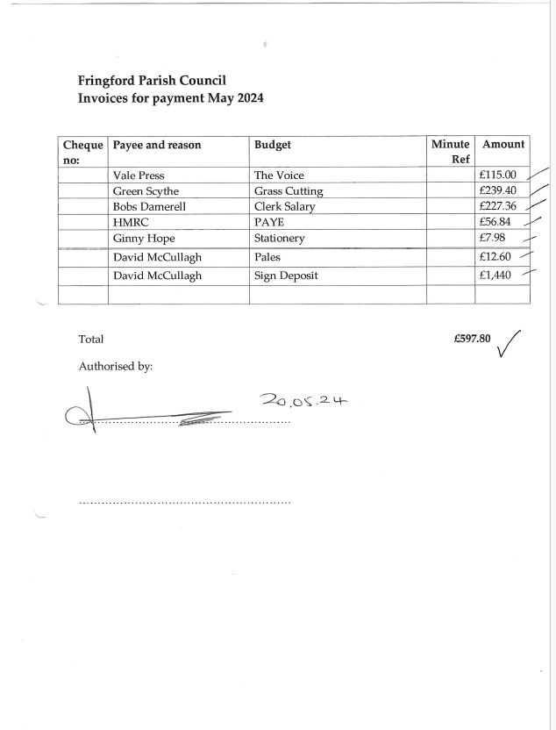

Appendix A – Chair’s Report

The Parish Council met 12 times between April 2023 and March 2024. As always, a wide variety of topics have been discussed as reflected in the minutes which are displayed on the Parish noticeboard and on the Village Website. Several significant topics have featured in the activities of the Parish Council this year, some of which have been ongoing since the previous year.

- Consultation with residents of planning appeals, relating to a proposed 6 property development on land off Wise Crescent and a 4-bedroom house on the corner or Rectory Lane and Farriers Close. Both appeals were granted, and planning permission granted.

- Consultation with residents on the planning application for a proposed gypsy traveller site on land off the main Bicester to Buckingham Road.

- Dealing with issues with various trees in the village.

- Plans to renovate parts of the Village Green and help to alleviate the parking problems – start date now confirmed as 21 July 2024.

- Improved the soak away pond area by cutting back and pollarding overgrown trees, new planting of wildflowers and bulbs. Installation of two benches including one as a memorial bench.

- Continued liaison with HS2 and the landowner/agent for these two projects, and Oxfordshire County Council on the highways scheme to improve the Green’s verges and parking.

- Successful application to introduce a 20mph speed limit and the purchase of signs and a Variable Speed Awareness monitor for Fringford Road.

- Repaired the stone wall by the school with a memorial to Queen Elizabeth II.

- Undertaken a resident’s survey to provide feedback for the refreshed Fringford Village Plan 2024.

- Contributed to the draft Cherwell 2040 Plan consultation that Fringford should be reclassified as a small village.

- Commissioned a resident’s survey to update the Fringford Village plan.

- Successfully achieved getting the Butchers Arms pub registered on the Cherwell DC Asset of Community Value register.

In a bit more detail on the key areas of activity…

Planning matters

The main matters that the Parish Council was involved in consulting with residents and submitting comments on plus attending meetings were the planning appeal for 6 houses on land off Wise Cresent 22/03741/F, and the planning appeal for a 4-bedroom house on land on the corner of Rectory Lane and Farriers Close. Both planning applications were originally refused by Cherwell District Council but on appeal the Planning Inspectorate granted planning permission for both schemes. The Parish Council commissioned the advice of a specialist planning Advisor to object to the proposed gypsy traveller caravan site on land off the Bicester to Buckingham Road. This was refused by Cherwell District Council on the grounds of highways safety and harmful impact on open countryside.

The work to renovate parts of the village green and alleviate the parking problems.

There are 2 projects totalling £134,000, obtained for the village by the Parish Council.

The village was fortunate to obtain HS2 grant monies from the road safety fund for a highway safety project for improvements to The Green approved by Oxfordshire County Council Highways. This includes a passing space on the road across The Green, wooden posts around The Green, repairs to the verges and the creation of 14 herringbone style car park spaces, to include disabled, parent &amp; child and standard spaces on the playground side of the road. A drawing of this can be viewed on the Parish Council noticeboard. A decorative village sign will also be installed on an oak post, like those in other villages.

HS2 grant monies also enabled general improvements which have included tidying and removal of dead wood in the soakaway pond area and planting of wildflowers and bulbs, the siting of two benches including a memorial bench and a water safety sign. The rebuilding of the old stone wall on the bend by the school which includes memorial stone to the memory of Queen Elizabeth II.

20’s plenty
The Parish Council has put up 20’s plenty signs in the Village. These are in advance of the legal speed signs which will be installed by Oxfordshire County Council. Along with the installation of a new digital vehicle speed monitor with faces erected on the Fringford Road entrance to the village to help people take notice and reduce their speed.

Asset of Community Value
Cherwell District Council has registered it an “Asset of Community Value”. This means that if the pub is put up for sale in the next 5 years, the Parish Council or related Community Interest Group would be given first refusal on its purchase. A six-month moratorium period will kick in during which the group has exclusive negotiating rights. The owner is not obliged to agree and, at the end of the period, can sell to whoever they like – but the moratorium can give local people a real competitive advantage.

Given the number of local pub closures, the parish council believes it would be worth exploring the options going forward. It’s great to see the pub developing under new management but it shouldn’t be forgotten that the previous two landlords really struggled, and the Butchers Arms is no out of the woods yet. Over the next 5 years closure remains a risk.

The Parish Council would like to form a small working group of volunteers to explore the feasibility of purchase and management if the option arose.

The initial tasks for the group would be to visit one or two community pubs to meet with the people who set them up. The objective would be to build a view as to how feasible it might be to do the same in our village if it became necessary. If it was considered feasible, the working group would then move on to carrying out some preliminary work putting together an outline plan as to how it might be achieved.

Residents Survey and update of Fringford Community Plan

21% of residents responded to a survey about the village, full results and how this will nform the updated village plan will be shared in June.

Finance

I am pleased to report once again that the Parish Council finances remain in a very good state with adequate reserves, only a small amount of which will be required for the two village green projects as costs have increased since the grants were awarded but the Parish Council has successfully managed to mitigate against large increases in costs.

Village groups and organisations
On behalf of the Parish Council, I would like to thank many villagers for their contribution to the community…

- The Village Hall Committee for their work to keep the amazing asset of the hall very well maintained and accessible. For organising and running village events and professionally promoting the use of the hall.

- Fringford Friends – for the coordinator and handful of volunteers supporting villagers when they need assistance.

- The members of the Cricket Club for maintaining the beautiful ground and keeping the tradition of cricket thriving in the village.

- The Butchers Arms Pub – for being a focal point for village life.

- Aunt Sally team resurrecting a time-honored village tradition alongside the pub and the cricket club.

- The Editorial team and sponsors of the Village Voice for keeping us up to date with village events.

- Administrators of the Fringford Mutual WhatsApp group – a very useful communication tool.

- The Church PCC and volunteers for looking after the church and churchyard and keeping it available to the community.

- Fringford School and Shelswell Pre-school – for providing excellent, local educational establishments for families.

- The group of volunteers for continuing to undertake the village litter picks and others who take the time to keep the village tidy.

- The Sewcial – for a creating and craft &amp; chat group in the village.

- The Village History Society – for looking after the historical information of the village and keeping the important memories of our village alive.

- The farmers who keep our hedges and verges in good shape.

All these people make a real difference and make Fringford the positive and attractive community we all enjoy. All these groups depend on individuals, and all are keen to attract more support so please, if you are interested, join in, and do your bit.

I would personally like to thank all the Parish Councillors and Bobs, the Parish Clerk for their time, effort, and commitment. The Parish Councillors all give up their time to attend meetings, read many documents, carry out planning consultations and undertake many other tasks. All the Parish Councillors are volunteers and make no claims for expenses on travel or other costs. So far, we have a good track record of attending meetings along with a commitment to and undertake projects in the background, all for the benefit of Fringford.
All villagers are entitled to attend Parish Council meetings and either speak at the beginning if there is something they wish to raise or observe the whole meeting. We meet in the Village Hall, usually, on the third Monday of most months at 7.45pm. If you would like to receive the agenda and minutes by email, please do let Bobs the Clerk know.

Councillor Ginny Hope
Chair
Fringford Parish Council.

Appendix B

FRINGFORD PARISH COUNCIL OBJECTIONS

24/00899/OUT Land Adjoining The Cottage, The Green, Fringford.

Outline application for construction of 9 detached dwellings, formation of new vehicular and pedestrian access, associated landscaping, drainage and associated works with all matters reserved except for access.

Context
Given the anticipated high level of public interest and the complexity of this application with its references to appeal decisions and housing land supply arguments, Fringford Parish Council respectfully request that this application is determined at Planning Committee level rather than at delegated officer level and that Oxfordshire County Council Highways team undertake a site visit for the reasons stated below in additional information.

It is important to note that this new application is not materially different to the previous application 21/02553/OUT which was refused on 27 September 2022. This new application and supporting documents do not appear to have been revised and have not addressed the previous reasons for refusal which were.

1. The application site remains outside the build-up limits of Fringford. The applicant attempts to argue that the land adjacent to Wise Cresent appeal decision (APP/C3105/W/23/3324251) should result in this application site being automatically regarded in the built-up limits of the village. Not all application sites are the same and each site should be assessed on a case-by-case basis. This site is different to the land adjacent to Wise Crescent in that it is surrounded by open countryside and does not have development on 3 sides.

2. Detrimental impact on the character and appearance of the area – nothing has materially changed in the physical circumstances of the site therefore the same detrimental impact would occur should this application be granted.

3. Fringford is now classed as a small village by Cherwell District Council, it has already been classed as unsustainable in terms of services, facilities, and public transport by an Appeal Inspector (APP/C3105/W/18/3204920 Fringford Cottage).

4. Drainage matters – no alternative means of surface water disposal has been proposed.

The Parish Council strongly objects to Planning Application - 24/00899/OUT on the following planning grounds:

1. The proposed site is not in a sustainable location. Fringford is now classed as a small village and does not have access to services such as shops, health services and transport services. Sustainability has been previously tested in the dismissed appeal at Fringford Cottage Main Street APP/C3105/W/18/3204920. Nothing has changed in this regard. Should the proposal be approved, it would create significant risk of opening unconstrained growth in an unsustainable location resulting in future planning applications for housing developments.

2. The proposed site is outside the village envelope as it falls within an area of open land outside the built up area of the village and it is currently used for grazing. It forms part of the open countryside which is an important part of the rural nature of the village setting. The proposal would detrimentally impact the landscape and dramatically change the village setting. The views in this part of the village would be adversely affected by the building of this relatively dense housing estate. Impact on the open countryside and rural setting has been previously tested in the dismissed appeal at Fringford Cottage Main Street APP/C3105/W/18/3204920.

3. The proposed development is of a relatively high density compared with the village as a whole. Nine large 4- and 5-bedroom properties with driveways and garages do not constitute in-fill or minor development that may be considered for a category A village, now re-classified as a Small Village by Cherwell DC.

4. The proposal would have a detrimental impact on the closest neighbouring properties, The Cottage, The Paddock and The Bakehouse as it will cause significant overlooking and loss of their current amenity. This goes as far as potentially causing harm to a vulnerable adult living at The Cottage due to his physical and mental health needs. For example the proposal suggests erecting a 2.5m fence effectively boxing in the rear of this property. We understand that separate representation will be made with regards to this.

5. No information has been provided on the impact of the proposed footpath on a protected oak tree, or that permission has been granted for the proposed footpath to join a private driveway. Oxfordshire County Council Highways representatives previously referred to this in their consultation response saying that the proposed footpath is an integral part of the safety of Crow Lane, however, they will need to re-examine this as the information is incorrect.

6. The proposal would have an impact on the setting of 3 listed buildings, The Bakehouse, Meadow Barn, and Green Farmhouse, detrimentally changing the rural in character setting. The application does not mention these buildings. Impact on the setting of listed buildings has been previously tested in the dismissed appeal at Fringford Cottage Main Street APP/C3105/W/18/3204920.

7. The proposal would have a negative impact on Crow Lane, detrimentally impacting the everyday experience and safety of all road users. The current narrow rural Crow Lane and village landscape will be detrimentally impacted by large stretches of hedgerow and old stone walls being removed, destroying the distinctive rural character of this entrance to the village. Stone walls are a feature of Fringford and local planning policies actively look to support their retention not their removal.

8. The proposal would have an impact on flooding and drainage risks. The site already floods, impacting the Bakehouse Pond causing the property to regularly flood, along with The Cottage and sewage overflow at the pumping station at The Paddocks.

The proposal appears to be contrary to both Cherwell’s Local Plan policies and national planning policy based on the above points of planning. We respectfully ask that the application is refused. Additional information sent to Jaqui Cox, Infrastructure Locality Lead,
Cherwell DC on 21 May 2024.

At the well-attended Parish Council meeting last night (20 May) residents raised many concerns about this proposed development and particularly about highway safety on the narrow single-track Crow Lane, called The Green on the developers plans. Also concerns about the proposed access and the proposed footpaths/s because without the permission of the owner of the private driveway, pedestrians would have to walk on Crow Lane. The Parish Council and residents felt that it is imperative that we have a Highways officer visit the site, a member of the Parish Council would be more than happy to meet them on site, should that be deemed appropriate.

There is NO REGISTERED FOOTPATH 218/5/10 (see letter below), running along the private driveway leading to The Paddocks and The Bakehouse. The owner of the private driveway has emphatically stated that he will not allow a new footpath from the proposed development to join his private driveway, see photo.

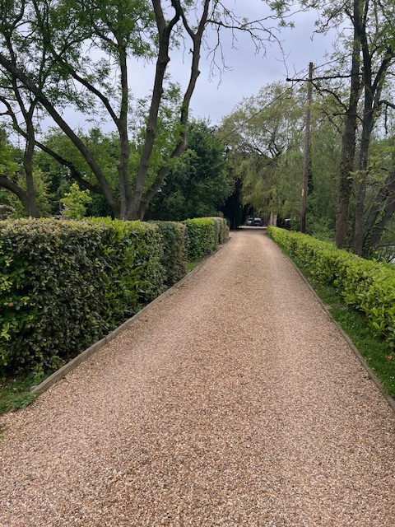

(private driveway)

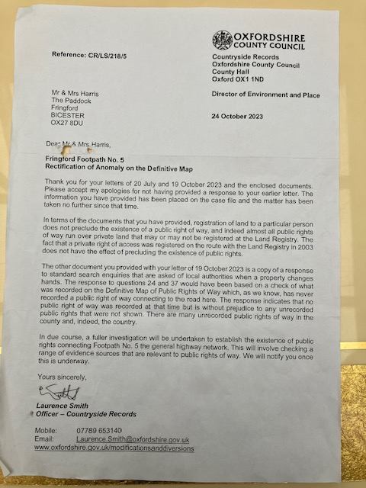

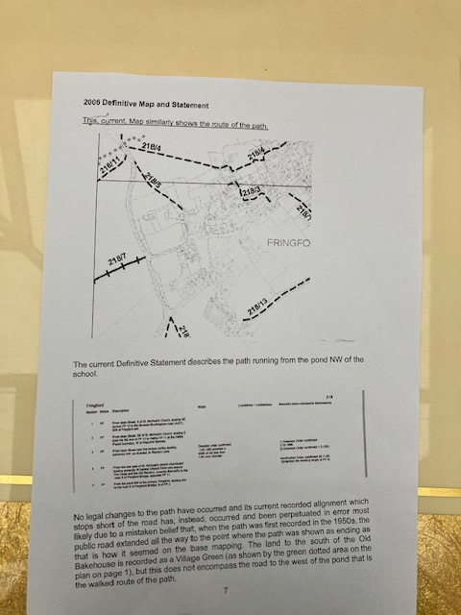

The second footpath as per the developers plans states a new 2-meter footpath running alongside of Crow Lane to join the entrance of the private driveway leading to the entrance where the private drive joins Crow Lane. This proposed footpath would mean the removal of an ancient stone wall, covered in ivy, for a 50-metre stretch that runs parallel to Crow Lane. This wall joins the wall belonging to The Cottage, adjacent to the protected oak tree, in the corner at this point the verge is 1.2 metres wide which would mean that the footpath would have to finish or extend into Crow Lane, which is unacceptable on safety grounds, see photos.

Highways officers previously commented that the footpaths are integral to the access and safety of the site. Therefore, without them the application should be refused on the matter of access.

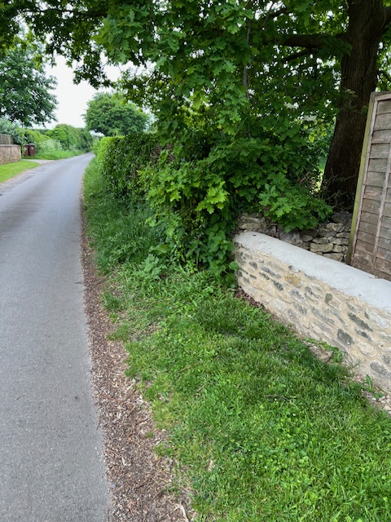

(wall joins the wall belonging to The Cottage, adjacent to the protected oak tree, in the
corner at this point the verge is 1.2 meters wide)

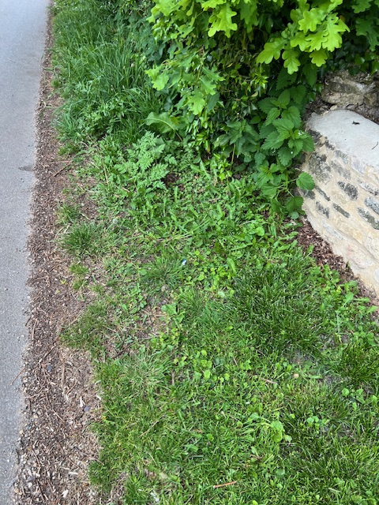

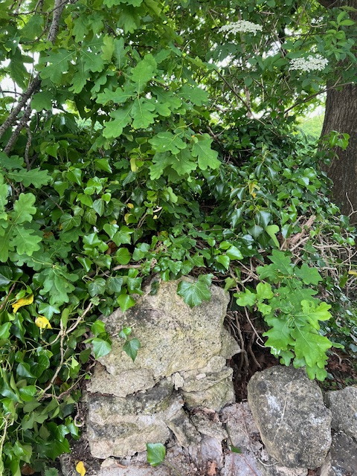

(Ancient stone wall covered by ivy)

Drawing PO2A (Stainsforth) provided by the developer shows a passing bay 15 meters in length on the opposite side of Crow Lane, the verge here reduces to 1 meter wide. Has the developer got the permission of the owners of Meadow Barn to create the passing bay? see photo.

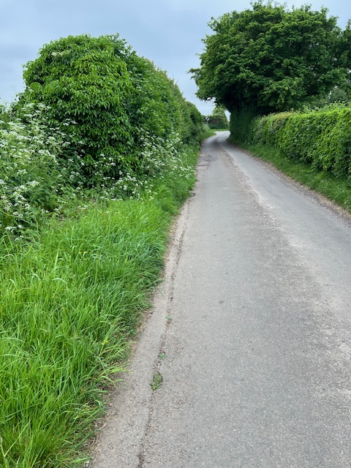

(photo showing the narrowness of Crow Lane and where the proposed passing bay would
be located)

The developers traffic census showed 227 movements per day and have stated that the new development would produce 40 new movements per day, which may be underestimated, but it is an increase of 20% on this narrow country lane, which we feel is unacceptable. Pedestrians already must stand on the grass verge when traffic is passing. Residents are also concerned that where Crow Lane joins the Hethe Road junction, the corner is almost blind and turning right out of Crow Lane means drivers have to pull out into the middle of the road to see if there is any oncoming traffic. See Appeal Dismissal for Meadow Barn APP/C3105/A/09/2118409 - point 12 stated that a main issue of that proposal for 2 dwellings on land opposite this site was highway safety.

All these important details are omitted from the developer’s application and plans. That is why we are insisting on a site visit by a Highways Officer please.

The Parish Council also wishes to draw your attention to the following previous refusal decision reasons;

23 September 2022 - point 4 of the planning officers decision report said there was inadequate information on the potential impact of the proposed footpath on the protected oak tree. There is still inadequate information.

23 September 2022 - point 8.36 of the planning officer’s decision report said that the CDC arborist objected due to the protected oak tree and there being no plan to mitigate against harmful impact.

23 September 2022 - point 8.36 of the planning officer’s decision report said that it is unclear on the matter of the proposed footpaths and the issue of crossing the private driveway. This new application fails to provide any further clarity - the reason for this is that they do not have permission from the owner of the private driveway.

21/00506/PREAPP - point 5.2 - the new footpath is poorly linked to the village. Appeal Dismissal for Meadow Barn APP/C3105/A/09/2118409 - point 12 stated that a main issue of that proposal for 2 dwellings on land opposite this site was highway safety.

Fringford Parish Council
21 May 2024

